**STAWELL SECONDARY COLLEGE**



79 – 97 Patrick Street, Stawell 3380 Victoria

Postal Address: PO Box 202 Stawell 3380 Victoria

Tel: +61 3 5358 1700, Fax: +61 3 5358 3096 Email: [stawell.sc@edumail.vic.gov.au](mailto:stawell.sc@edumail.vic.gov.au)

School No: 01/8731/29  
 Provider Name: Department of Education and Early Childhood Development, Victoria. CRICOS No: 00861K

6 November 2023

Dear Parent/Guardian/Carer,

Stawell Secondary College would like to thank you for your support in 2023.

We are now looking forward to another exciting year of teaching and learning ahead and would like to advise you of Stawell Secondary College’s voluntary financial contributions for 2024.

Our Stawell Secondary College School Council are very aware that families are facing a difficult financial climate with many of the costs associated with children continually increasing. With all of this in mind, our School Council have made the decision that there will be no increase from the 2023 Voluntary financial contributions for 2024.

Schools provide students with free instruction to fulfil the standard Victorian curriculum and we want to assure you that all contributions are voluntary. Nevertheless, the ongoing support of our families ensures that our school can offer the best possible education and assistance for our students. We want to thank you for all of your ongoing commitment. This has made a huge difference to our school and the programs we can offer.

Within our school this commitment has allowed us to offer our students a number of advantages including a wider range of subjects, special curriculum experiences and involvement in exciting local events.

For further information on the Department’s Parent Payments Policy please see a one-page overview attached.

Also included is all the information you require to assist you in ordering your 2024 Year 11 VCE student’s books and the dates for the school year.

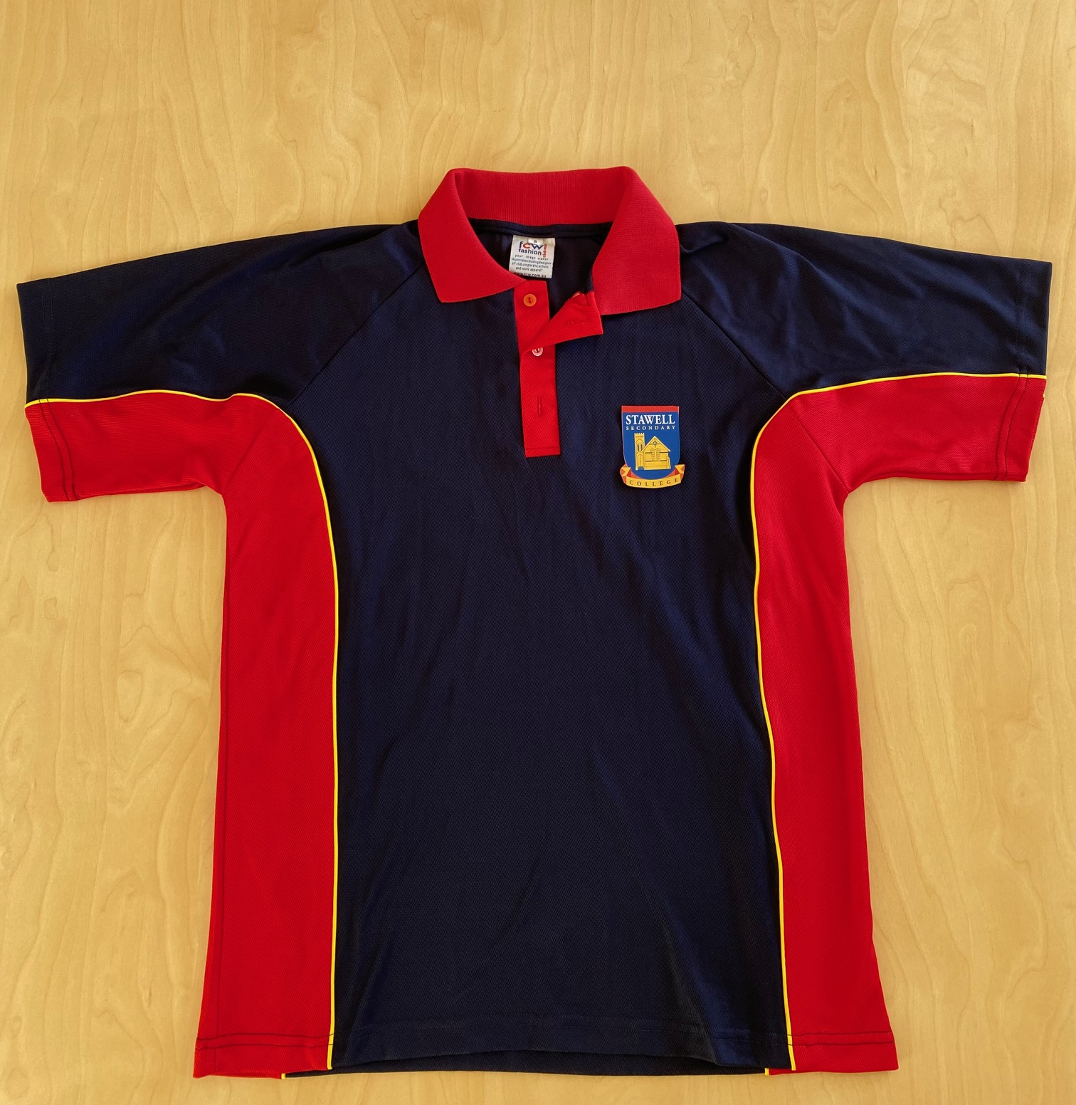

We are thrilled to announce that, following the feedback

from students and parents, we are introducing a new

school polo top from the start of 2024.

**The most exciting news is that EVERY student will receive**

**a free polo top at the commencement of 2024**. There will

be more information closer to the end of the year on how

your children will receive their complimentary tops.  
Our new top will be available from Fosters Mensland in   
January 2024.

Students will be able to also wear their existing white polo

top until the end of 2024.

Another change to our school uniform is that our approved footwear will be black shoes or boots with no visible logo or patterns.

The final change to our school uniform will be the introduction of a new sports top. This top will replace the previous red top with a new modern design and improved fabric. The current red polo top may be worn until the end of 2024. The new design will be available from Fosters’ Mensland in January 2024.



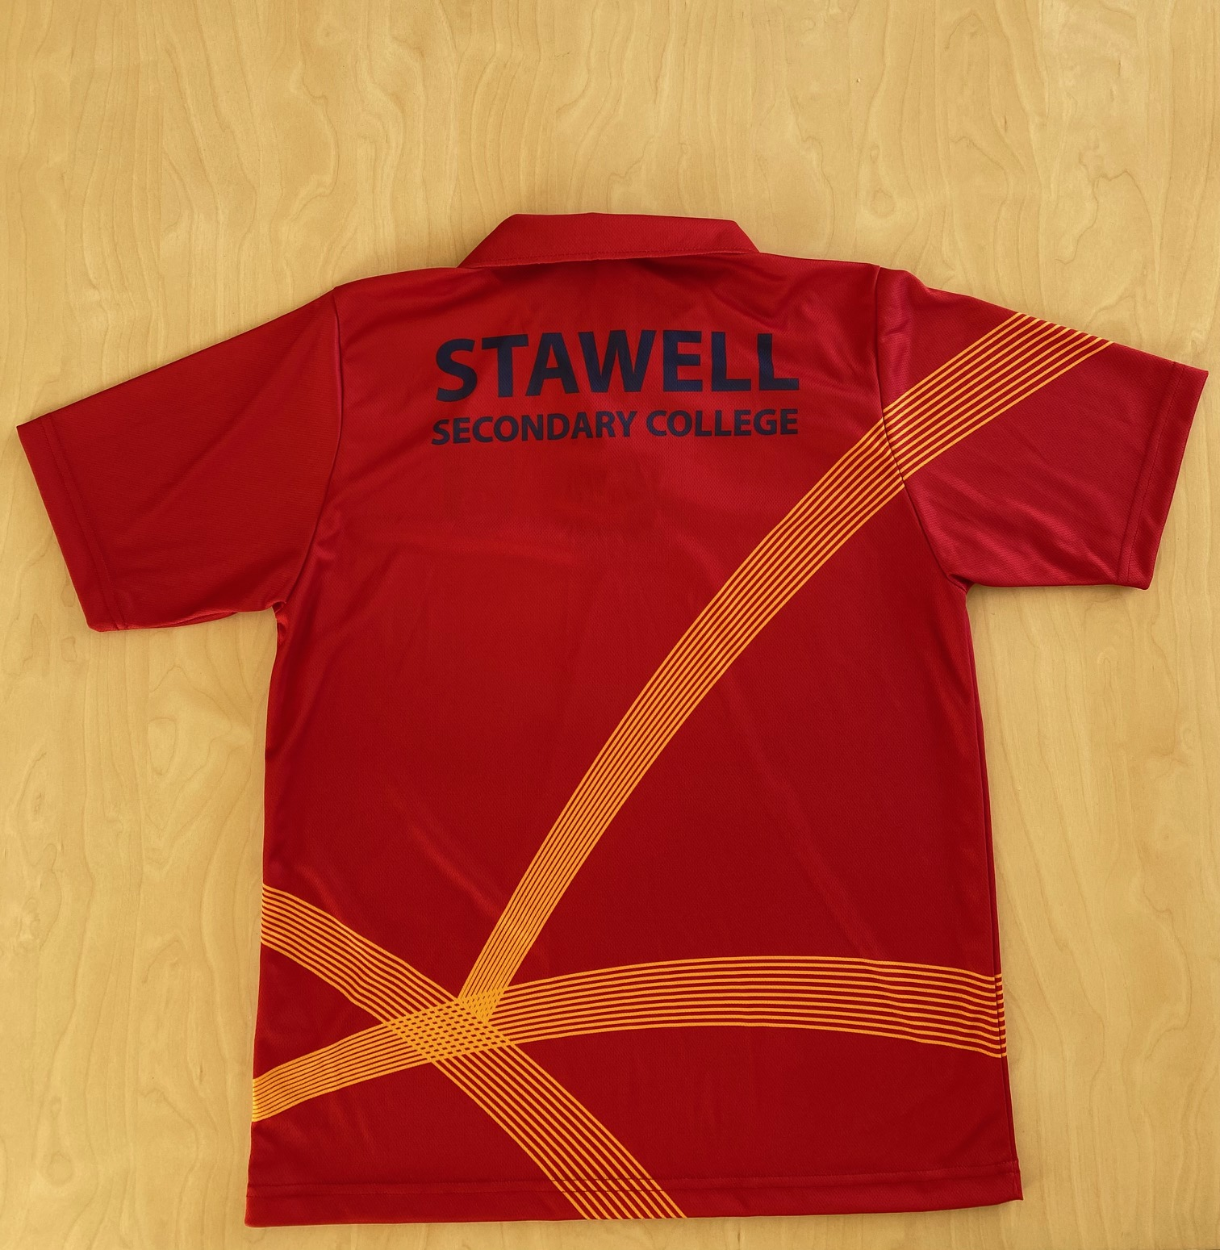

Please do not hesitate in contacting the school if you have any concerns on any of the information provided in this letter.

Yours sincerely,

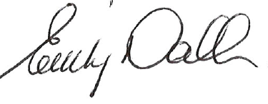



Murray Hart Emily Dalkin

Principal School Council President



**STAWELL SECONDARY COLLEGE**

79 – 97 Patrick Street, Stawell 3380 Victoria

Postal Address: PO Box 202 Stawell 3380 Victoria

Tel: +61 3 5358 1700, Fax: +61 3 5358 3096 Email: [stawell.sc@edumail.vic.gov.au](mailto:stawell.sc@edumail.vic.gov.au)

School No: 01/8731/29  
 Provider Name: Department of Education and Early Childhood Development, Victoria. CRICOS No: 00861K

|  |  |
| --- | --- |
| Curriculum Contributions - items and activities that students use, or participate in, to access the Curriculum | Amount |
| **YEAR 11 2024** |  |
| Year 11 Student ID Card | $5.00 |
| VCE / VCAL subject consumables, classroom materials and activities | $159.00 |
| Year 11 whole school events   * Athletics carnival - entry and transport ($1.50) * Swimming carnival – entry and transport ($2.50) | $4.00 |
| **Other Contributions -** for non-curriculum items and activities | **Amount** |
| School Sports Victoria membership | $7.00 |
| Student wellbeing programs | $30.00 |
| **Total Amount** | **$205.00** |

**Educational items for students to own.**

Our Book List, which displays a list of items that the school recommends you purchase from Campion Books for your child to individually own and use, is included with this letter. Ordering with Campion Books is only available online. Families may choose to purchase some or all the items elsewhere, but we encourage you to use the Book List as a guide to what you are invited to purchase.

The log in details are [www.campion.com.au](http://www.campion.com.au) using “PGPB” as your code. You will also be able to access the Book List using the school website: [www.stawellsc.vic.edu.au](http://www.stawellsc.vic.edu.au)

A one page ‘How To’ sheet is included with this letter.

If you require assistance in lodging your book list with Campion, please phone our school office on 5358 1700 to make an appointment for our office staff to assist you to enter your order or to answer any of your questions.

All Book Lists should be completed by Sunday 17 December 2023 to ensure your students will have all of their items for the first day of school in 2024.

You may select to have your Book Pack delivered to your home in January 2024 or you will be able to collect the pack from the school on Monday 29 January 2024 from 12 – 4 pm in the school’s Assembly Hall.

All students in Years 7 and 8 will study all subjects on the Book List. If your student is in Years 9 - 12 please find enclosed a list of your student’s subjects to assist in your Book List selection.

**Extra-Curricular Items and Activities**

Stawell Secondary College offers a range of items and activities that enhance or broaden the schooling experience of students and are above and beyond what the school provides in order to deliver the Curriculum. These are provided on a user-pays basis.

|  |  |
| --- | --- |
| Extra-Curricular Items and Activities | Amount |
| Optional Year 11 two-night school camp – Yr 11 Futures Camp | $400 |
| Optional Year 11 Interschool Sports program | To be confirmed when destination  and events are known |
| Optional Year 11 private music lessons | $160 ($80 per semester) |
| Total Extra-curricular Items and Activities | |

**Financial Support for Families**

Stawell Secondary College understands that some families may experience financial difficulty and offers a range of support options, including:

* the Camps, Sports and Excursions Fund

Every Victorian child should have access to the world of learning opportunities that exist beyond the classroom. The Camps, Sports and Excursions Fund will ensure that no student will miss out on the opportunity to join their classmates for important, educational and fun activities.

CSEF will be provided by the Victorian Government to assist eligible families to partially cover the costs of school trips, camps and sporting activities.

If you hold a valid concession card or are a temporary foster parent you may be eligible to for CSEF. Cards must be valid with Centrelink. Students can be aged from 6 to 18 years old. If a student is the holder of a Youth Allowance type card in their own name which is valid, the parent is eligible to apply for the CSEF.

The allowance will be paid to the school to use towards a child’s expenses relating to camps, excursion or sporting activities.

The annual amount per student is $225 for every secondary school student of eligible families, and payments will be made into the applicant’s school account.

How to apply: On Monday 29 January 2024 contact the school office to obtain a CSEF Application Form or download from www.education.vic.gov.au/csef. A copy of your Centrelink Concession Card will be taken when you return the completed form to school. A reminder will be published in the school newsletter, Connections, early next year.

If you have any questions please contact Marie Mcaloon, Business Manager.

* contact with a local community group who work with our school.

For a confidential discussion about accessing these services, or if you would like to discuss alternative payment arrangements, contact:

Marie McAloon

Ph: 03 5358 1700 Email: [Marie.Mcaloon@education.vic.gov.au](mailto:Marie.Mcaloon@education.vic.gov.au)

Every effort will be made to assist our families.

### Payment methods

There are a number of options available to parents to finance all costs associated with your student’s education at Stawell Secondary College:

1. Payment in full. This payment can be by cash, cheque or EFTPOS for all debit and credit cards.
2. Parents can arrange regular direct deductions by contacting their bank or employer or using internet banking facilities. Parents choose the amount and the preferred regularity eg weekly, fortnightly or monthly. Parents may suspend or cancel these payments at any time. This process can commence any time after the enrolment form is submitted.

Families choosing this method of payment are not required to send individual payments for Extra-Curricular Items and Activities such as camps and sport events.

To deposit directly to the school please use the following details and quote your family name or your student’s name as a reference.

Account Name: STAWELL SECONDARY COLLEGE

Bank: COMMONWEALTH BANK OF AUSTRALIA

BSB: 063-528

Account Number: 10009073

Details: Student’s Name

1. BPAY facilities are available. Your relevant information will be available from the School Office.

### Refunds

### Parent requests for refunds are subject to the discretion of the school and made on a case-by-case basis. Refunds will be provided where the school deems it is reasonable and fair to do so, taking into consideration whether a cost has been incurred, the Department’s Parent Payment Policy and Guidance, Financial Help for Families Policy and any other relevant information.

**2024 SCHOOL DATES**

Monday 29 January 2024 School Office open from 8.30 – 4.00 pm for payment of Curriculum Contribution & CSEF applications.

Collection of Campion Book Packs from Assembly Hall 12 – 4 pm

Tuesday 30 January 2024…… Pupil Free day as Staff attend Professional Development

Wednesday 31 January 2024 All Year 7 & 12 students attend school.

Thursday 1 February 2024…… All students attend school

Term 1 finishes ………… 28 March 2024

Term 2 15 April to 28 June 2024

Term 3 15 July to 20 September 2024

Term 4 7 October to 20 December 2024

**SCHOOL UNIFORM**

Stawell Secondary College school dress.

Stawell Secondary College tartan skirt or approved navy trousers or approved navy shorts.

Stawell Secondary College navy and red polo top with logo.

Stawell Secondary College red jumper with school logo or Stawell Secondary College navy blue polar fleece with school logo or Stawell Secondary College rugby top with school logo.

Stawell Secondary College navy winter jacket with school logo

Black or white socks or navy tights.

Plain Black shoes or black boots with no visible logo or pattern.

Plain navy scarf, plain navy approved beanie or navy beanie with Stawell Secondary College logo or plain head scarf (school colours)

**Sports Uniform**

Stawell Secondary College red Sports and Physical Education Polo Shirt with logo, navy shorts, track pants and sports shoes.

**House Sports Uniform**

House-coloured t-shirt borrowed for House Events from House Leader and returned on the day.

Sports footwear.

**Year 12 Jacket**

Must be ordered through the school in Term 4 of previous year to starting Year 12.

**Sun Smart policy**

In line with this policy, during Terms 1 and 4, all students are encouraged to wear an approved broad-brimmed school hat when outside. This includes lunchtime and recess. Aside from headscarves worn for cultural reasons, hats should not be worn inside. Hats are supplied to all new students and replacement hats are purchased from the school canteen.

**parent PAYMENTS policy ONE PAGE OVERVIEW**

|  |  |
| --- | --- |
|  | FREE INSTRUCTION   * Schools provide students with free instruction and ensure students have free access to all items, activities and services that are used by the school to fulfil the standard curriculum requirements in Victorian Curriculum F-10, VCE and VCAL. * Schools may invite parents to make a financial contribution to support the school. |

|  |  |  |  |  |
| --- | --- | --- | --- | --- |
|  | PARENT PAYMENT REQUESTS  Schools can request contributions from parents under three categories:   |  |  |  | | --- | --- | --- | | Curriculum Contributions  Voluntary financial contributions for curriculum items and activities which the school deems necessary for students to learn the Curriculum. | Other  Contributions  Voluntary financial contributions for non-curriculum items and activities that relate to the school’s functions and objectives. | Extra-Curricular Items and Activities  Items and activities that enhance or broaden the schooling experience of students and are above and beyond what the school provides for free to deliver the Curriculum. These are provided on a user-pays basis. |  * Schools may also invite parents to supply or purchase educational items to use and own (e.g. textbooks, stationery, digital devices). |

|  |  |
| --- | --- |
|  | FINANCIAL HELP FOR FAMILIES   * Schools put in place financial hardship arrangements to support families who cannot pay for items or activities so that their child doesn’t miss out. * Schools have a nominated parent payment contact person(s) that parents can have a confidential discussion with regarding financial hardship arrangements. |

|  |  |
| --- | --- |
|  | SCHOOL PROCESSES   * Schools must obtain school council approval for their parent payment arrangements and publish all requests and communications for each year level on their school website for transparency. |